Christopher Asbrock

Knight Quest

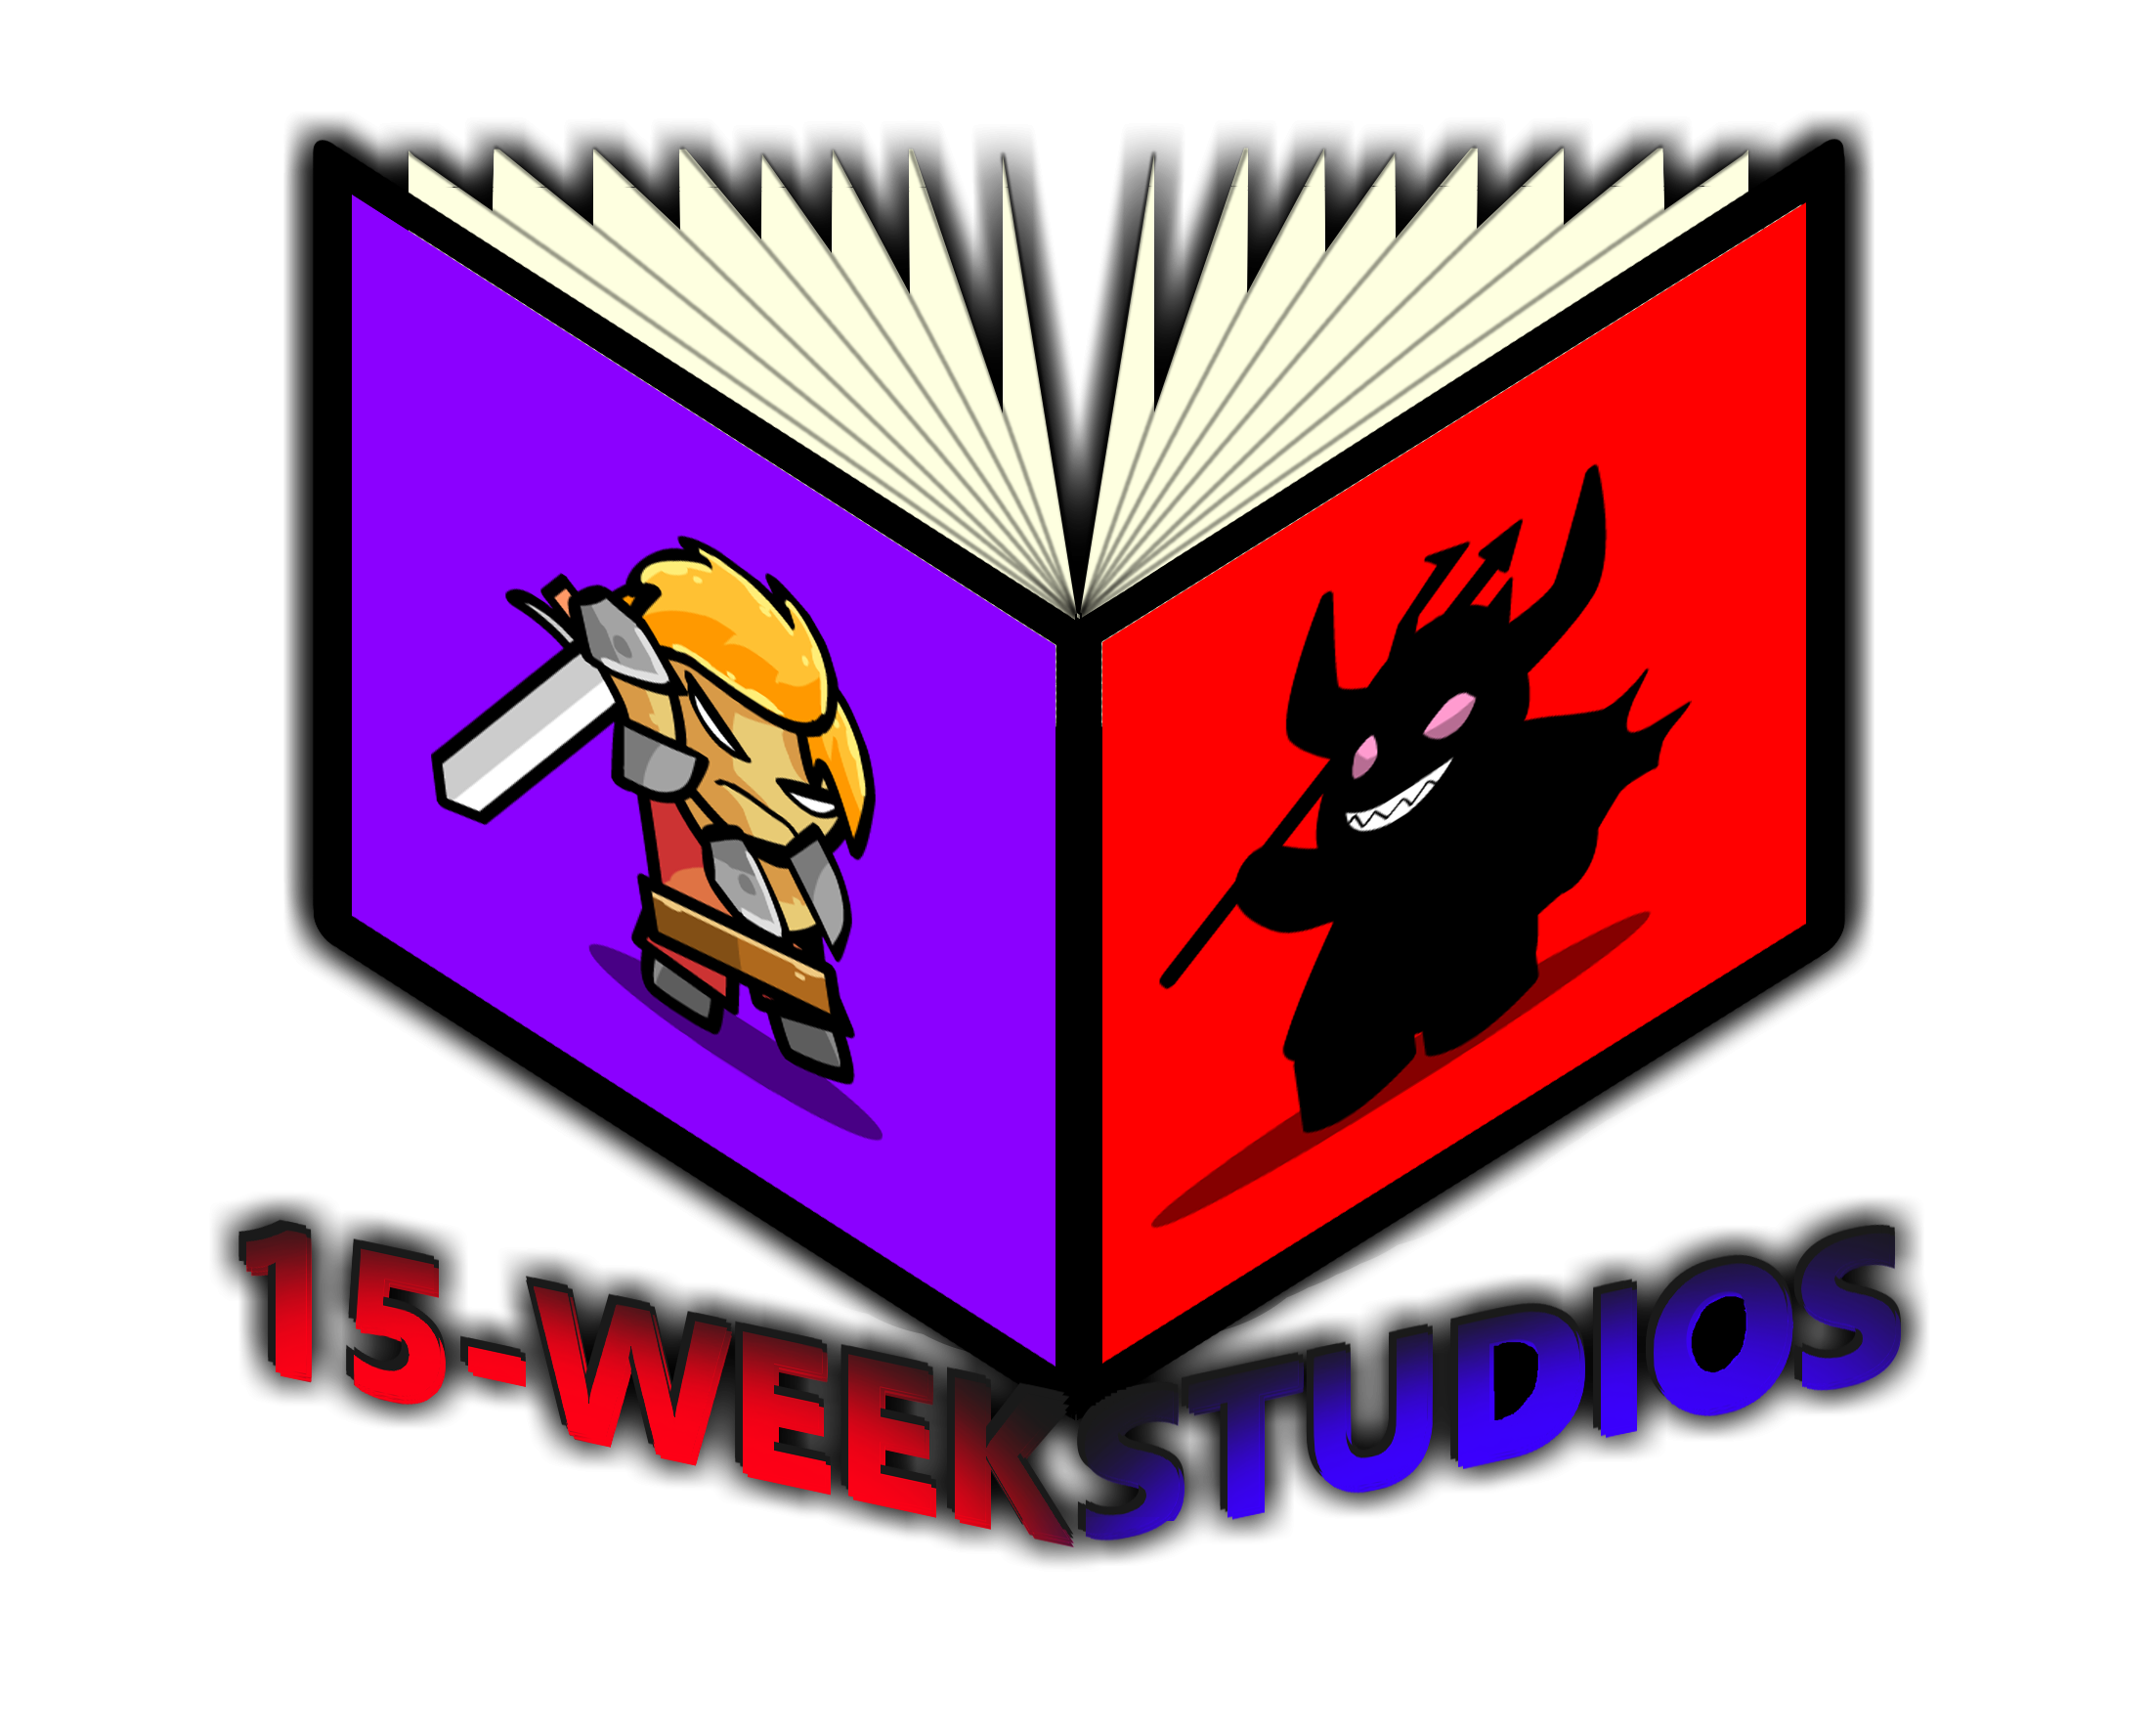

# Table of Contents

Table of Contents 2

Executive Summary 3

Program Usage 4

Reports 11

Testing Plan 12

Deployment Plan 13

Maintenance Plan 14

System Architecture 15

Executables 17

Code Architecture 18

External Files & Data 21

Programming Language | C#.NET 22

Project Classes 23

Project Modules 24

Program Start and End Flow 25

Summary 26

APPENDIX B (BUILD AND RELEASE PROCESS) 27

APPENDIX C (CLIENT INSTALLATION INSTRUCTIONS) 28

APPENDIX D (DEVELOPER SETUP INSTRUCTIONS) 29

APPENDIX E (Catchall Project Reflection) 30

# Executive Summary

15-weeks studio needs a new video game to introduce to the market. In order to gain attention, I propose we develop a game called “Knight Quest” that captures two popular genres and combines them: Adventure games and RPGs. Where we can take the explorative hook from adventure games, such as The Legend of Zelda, and add additional growth elements, such as games like Final Fantasy.

These two aspects of the game are both easy to implement and engaging to the player base for their simplicity and ease of use, where we will be able to attract a wide audience of casual gamers looking for a simple form of escapism, that is both entertaining and feels like they are making progress. The primary gameplay will allow for moving, jumping, and attacking. To keep players entertained, we will offer the player a 3D world to explore.

They will be able to

* Collect items that give experience or health
* Gain levels increasing their stats
* Fight various different enemies that walk, jump, and fire projectiles
* Fight 2 bosses, a dragon, and a devil boss with two phases
* Save their progress so they can immediately start again where they left off.

In order to keep development simple, we will forgo the typical 3D development with polygon characters and animations, and produce 3D based 2D sprite assets that are oriented towards the camera. This will allow them to be easily and quickly animated while still keeping the world attractive and charming. We will also keep requirements simple, such as limiting complex elements, such as enemy AI, to reasonable standards, i.e., a simple state driven system that can be easily programmed and tested.

In addition to this, we will be able to take advantage of free tools available on the internet to cut down on many costs. Tools such as the Godot Game engine, a powerful but simple game development environment; Kirita, a dynamic image editor; and Blender, animation software, will allow us to handle major asset development and management with unit costs. We will also be able to save costs by using relatively cheap asset packs that will contain various royalty free sprites, sounds, and music we can use. The main cost of the proposed product will mainly revolve around programming hours, unit costs for some ambient software needed, and various project management and administration fees.

By taking advantage of the many tools available, a simplistic design pattern, and the ideas popularized by well-known video game genres, we will be able to create a small but effective game that appeals to a wide variety of casual players and will be inexpensive and quick to produce.

# Program Usage

## Save Menu | Saves current in game stats and accomplishments to a file.

The Save game menu takes the current stat of the game and gives a choice of 3 files. Once the save button is clicked an encrypted file with the state of the game is written. This way the player can close the game but save their progress.

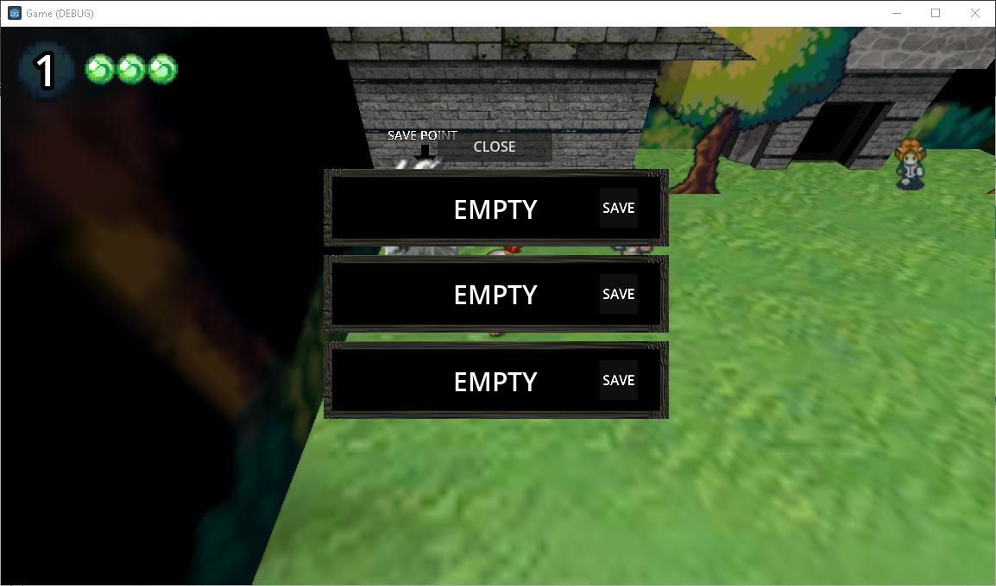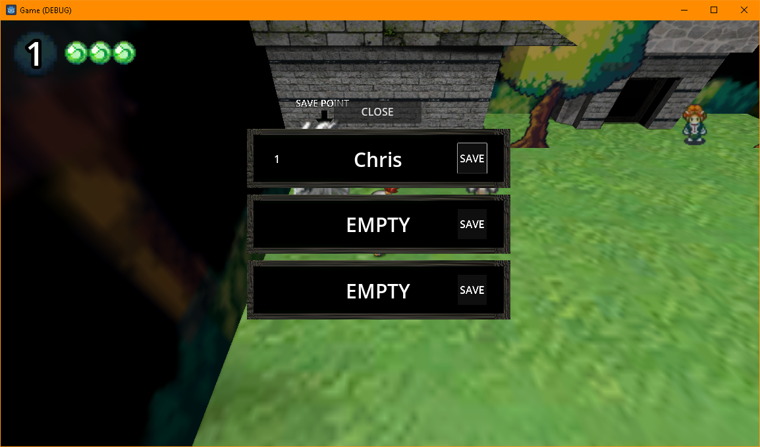

## Load Menu | Looks for files to open so it can restore the game to previous progress.

The load menu searchs the %Appdata% game folder for save files. If they exit it will read the players name and level. Once the player click the load button it will read all of the data and restore the game the player saved.

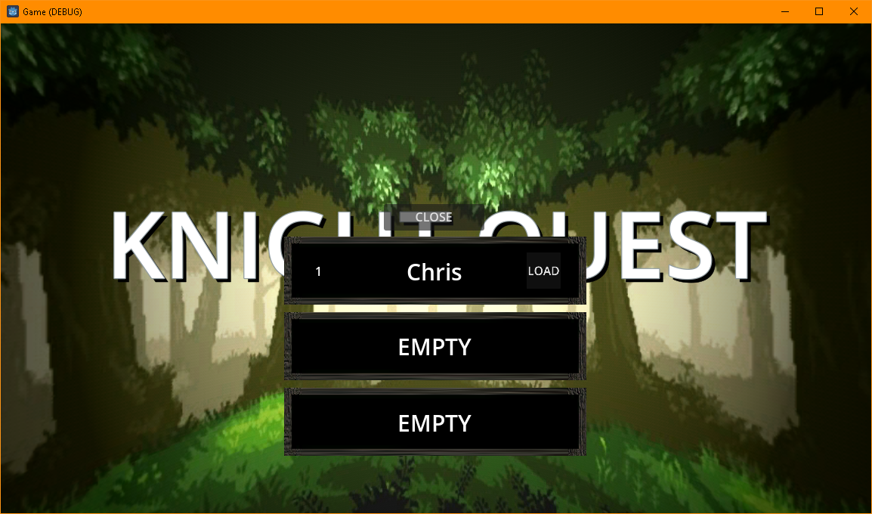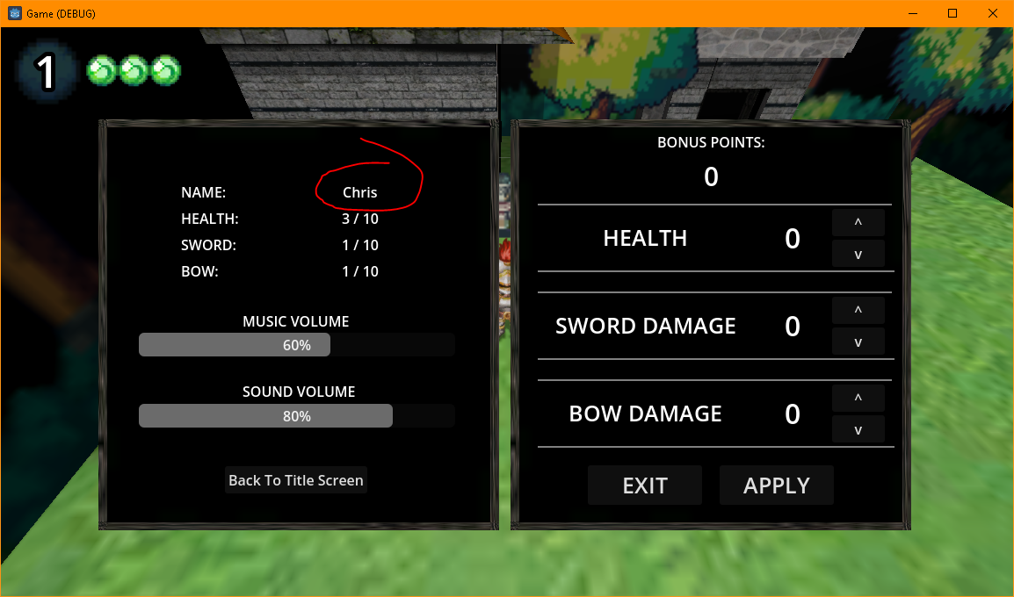

## Healing Bed | Provides a bed for the player to sleep in to heal damage taken during gameplay.

The bed is in the main town and allows the player to heal themselves without needing to collect items. All they have to do is walk into the same area the bed is in and it will appear like they got into the bed because of the angle. As long as the player is in that area they’re health will gradually heal.

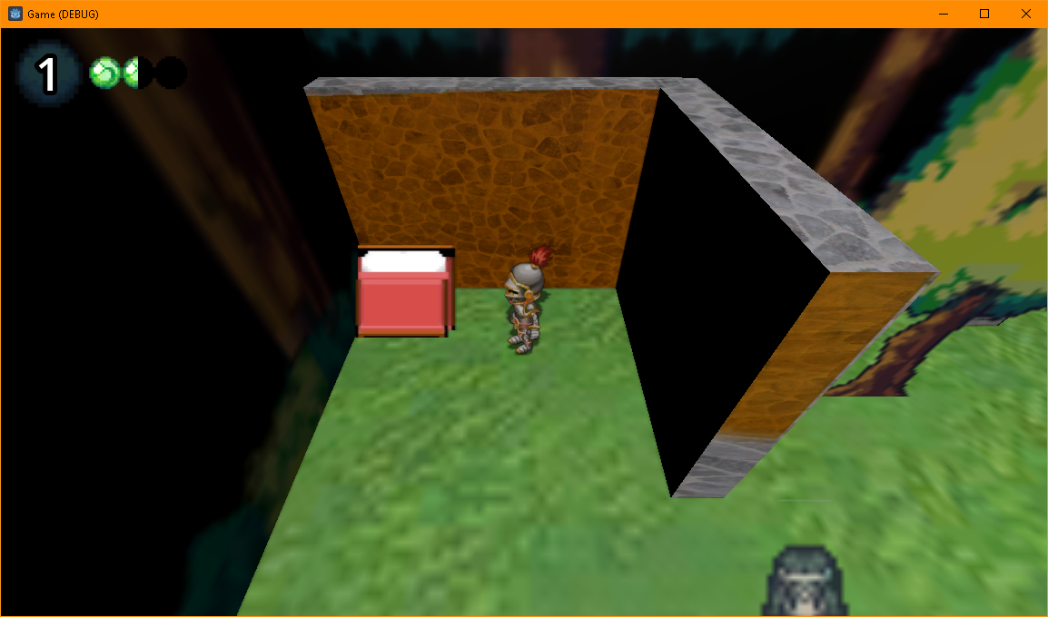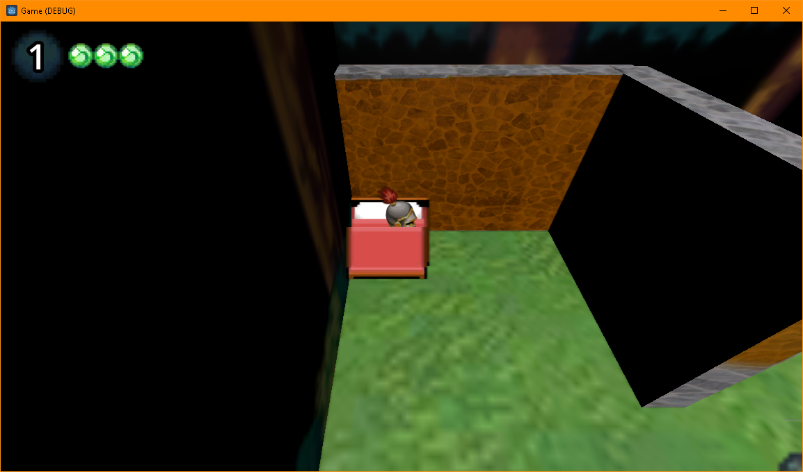

## Jump puzzle 1 | Teaches the player to jump on platforms to get to unreachable places.

A slow-moving platform that runs into an area that is too high to jump to. It allows the player to lean the jumping mechanics of the game.

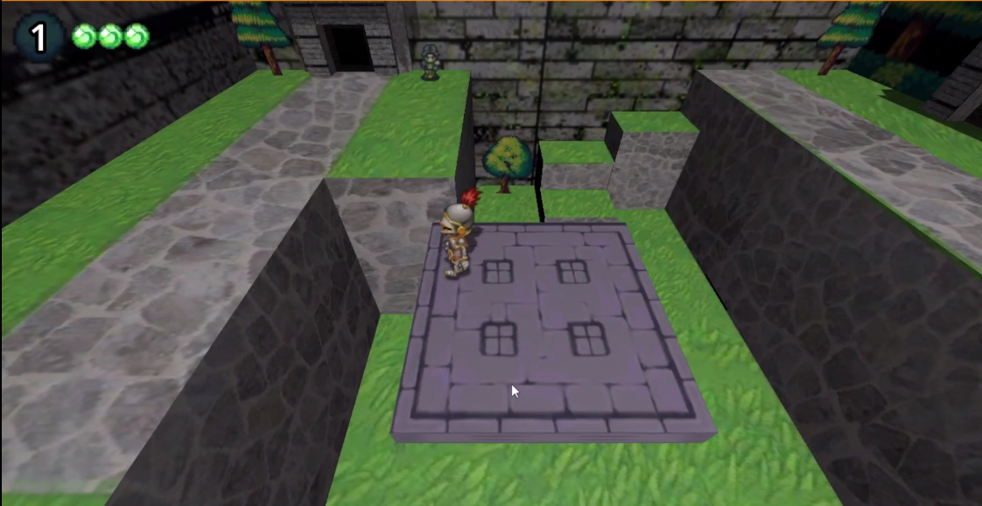

## Button puzzle 1 | Teaches the player about the button object.

The game has several buttons to hit and the first button puzzle teaches the player that the buttons in each room may function differently. In this case the play need to find a way to make all buttons blue when each button hit changes the hit button and the surrounding buttons to the opposite color. Once they are all blue the door opens.

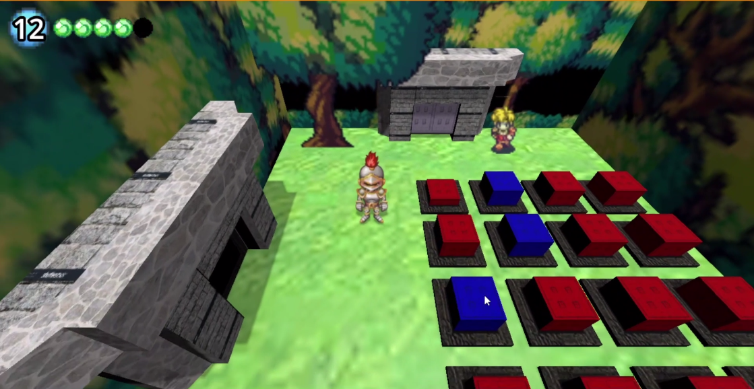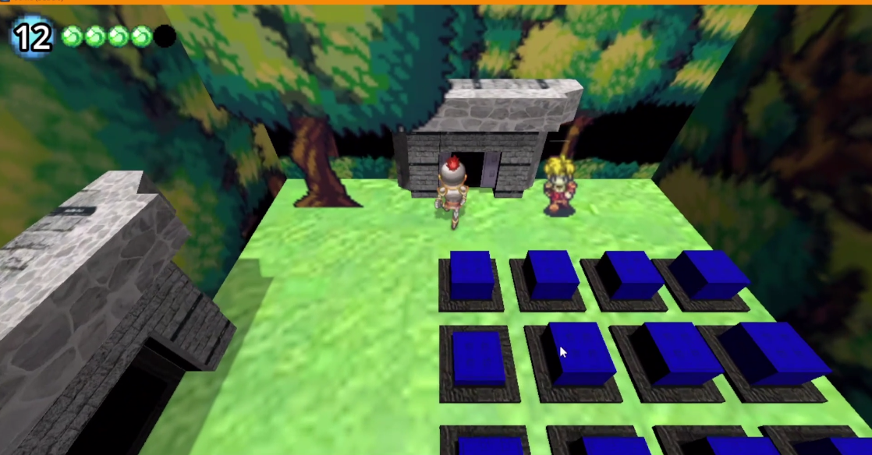

## Button/Jump puzzle 1| Program Usage Description

fast-moving platforms that runs into an area that is too high to jump to. It allows the player to learn the extent of jumping mechanics. There is also a button that will pause the platforms to make the jump easier

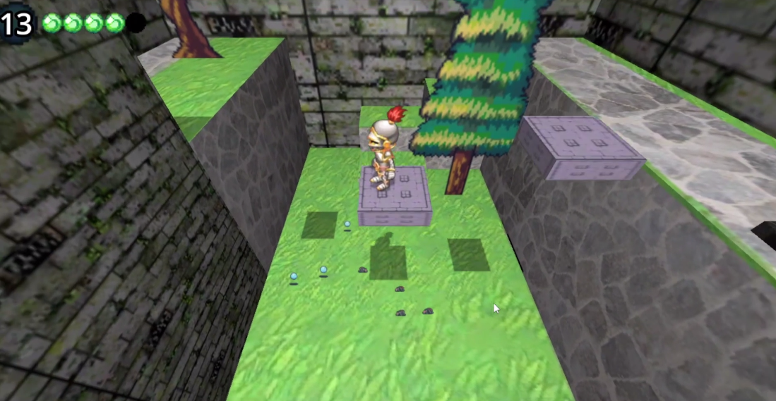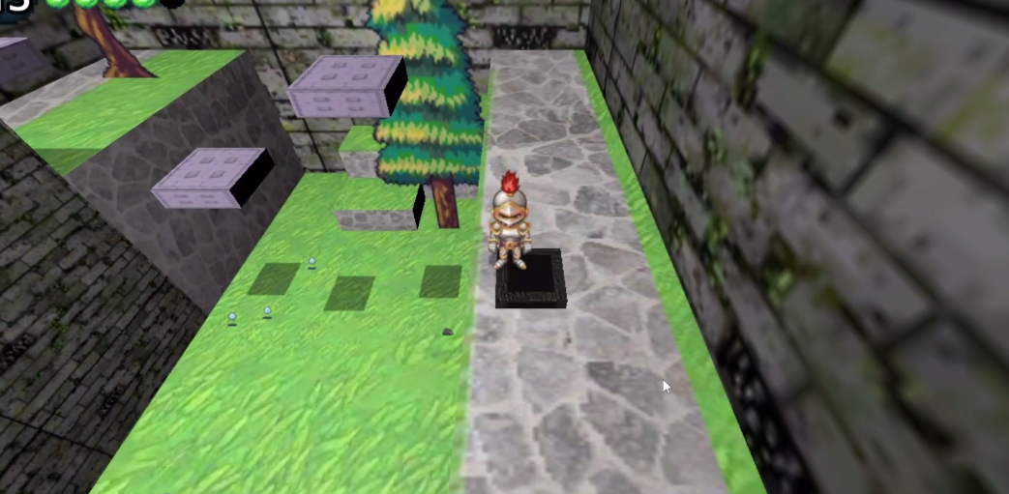

## Leveling System | Exp earned from beating enemies can level the player

As the player beats enemies the enemies will drop blue orbs

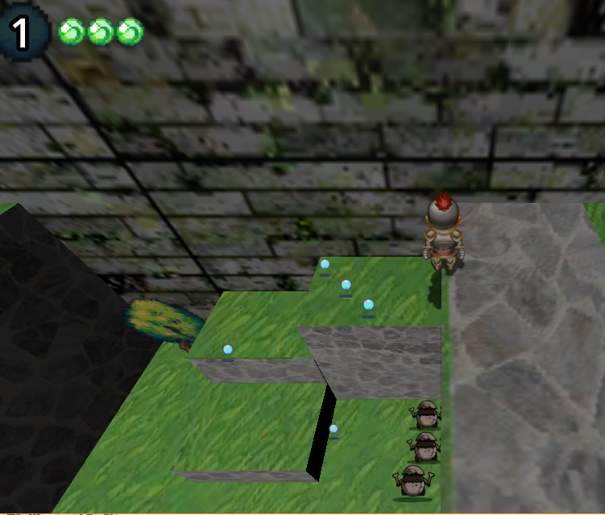

Collect enough and you can level the player up.

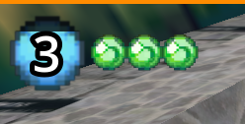

Each level gained adds bonus points that can be added to the players stats to make them more durable or stronger. To do this all the players need to do is bring up the menu with the Enter button and use the arrows to move the points to the desired stat. Click Apply with the mouse to apply the change.

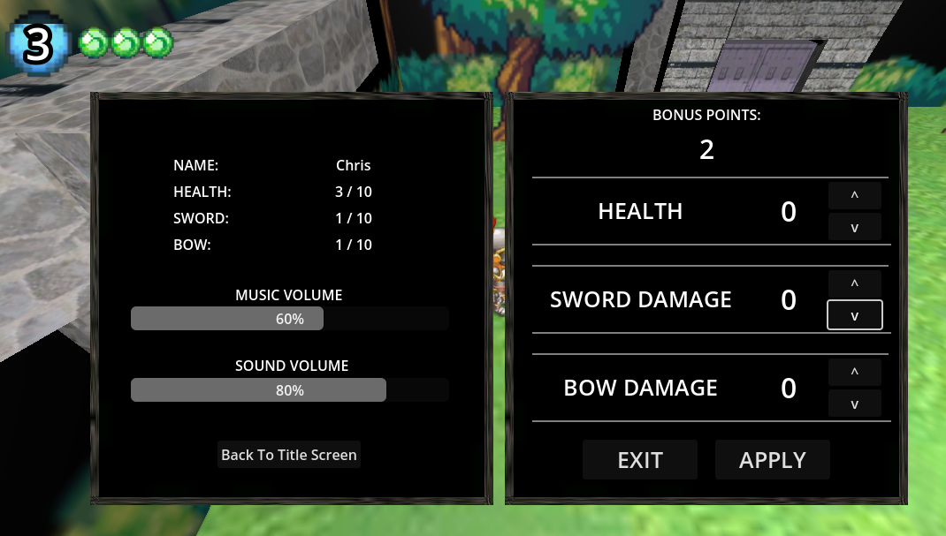 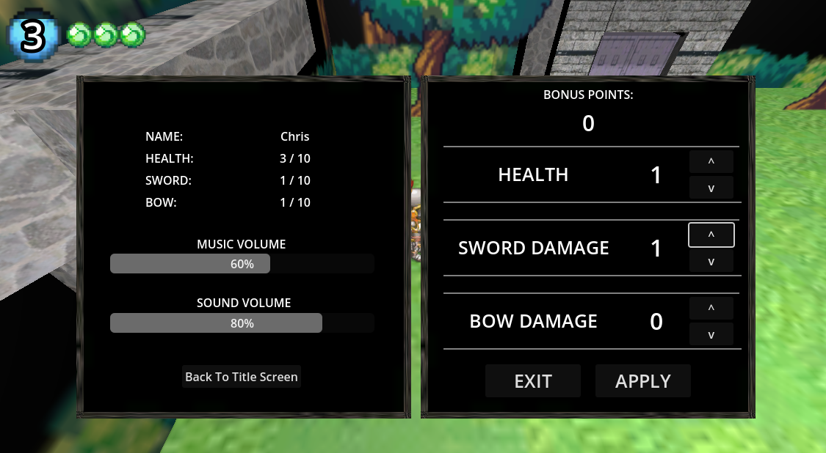 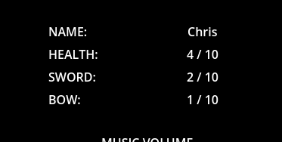

## Game Over | The player effectively fails and needs to start over

If the player’s health ever reaches 0 the player will get a Game Over screen and have to start over. They will be able to load an old save game so they will only lose the progress after their last save point.

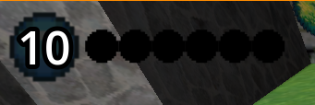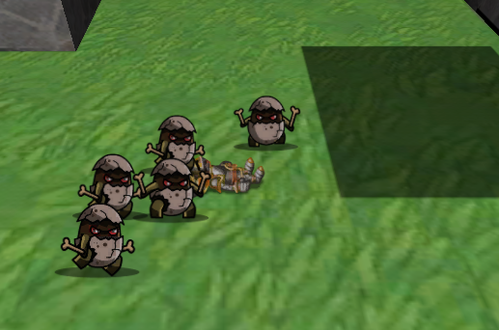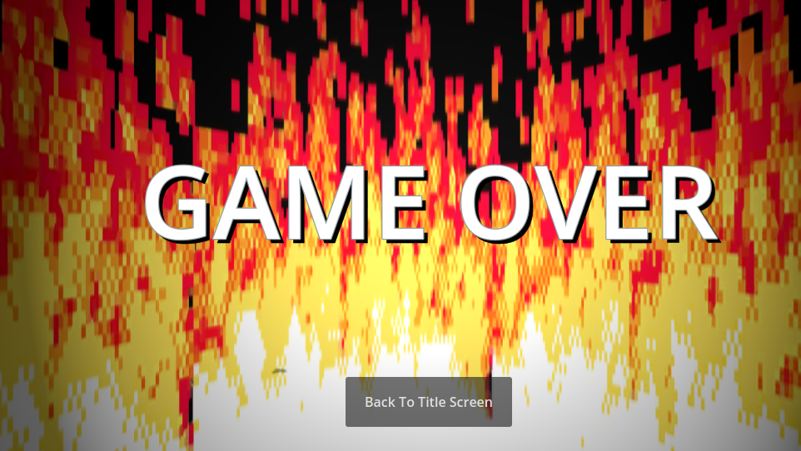

## Sword Attack | The player attacks in the direct they are facing with their sword.

Hitting the “UP” key will cause the player to swing their sword. This creates a hitbox that will strike any enemies around the player. The damage is based on the Sword Damage stat.

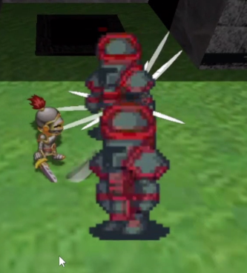

## Shoot Arrow | The player shoots a projectile that will hurt the enemy it hits.

The player can use the “LEFT” arrow to shoot an arrow in the direction they are facing. Much like a sword swing, this will cause damage based on the Bow Damage stat. The arrow will continue flying and is a way to attack without getting to close to the enemy

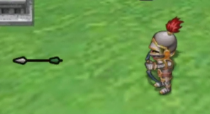

## Enemies | Various enemies that go after the player as the player attempts to make it through the game.

Each enemy is slightly different in how they function but they all work as obstacles for the player

|  |  |
| --- | --- |
| EGG  Small enemies that just walks towards the player |  |
| BAT  Hang out high in the air out of view. The player can hear them when they spot the player. After they see the player, they will occasionally swoop down and try to hit the player. |  |
| SPIDER  Small spiders jump towards the player. Weak but harder to predect than the EGG enemy |  |
| RED KNIGHT  Knights that walk towards the player. Similar to the EGG enemy, but the RED KNIGHT has much more defense. |  |
| BLUE KNIGHT  Upgraded red knights. Instead of walking directly at the player they line up horizontally before walking down towards the player. Much more defense than a RED KNIGHT, and immune to hit back. This means the player needs to plan attacks to swing and move away before they are hit. |  |
| MAGE  Warp to serval points on the map before charging up and shooting a fireball. They especially like to go to high ground and attack the player while they are trying to solve a puzzle or busy with other enemies. |  |
| GOLEM  The toughest of all the enemies, immune to knock back and bow damage. In addition to that, instead of attacking the player directly they get close and slam into the floor to produce huge shockwaves that need to be jumped over. |  |

## Boss One| A tree head dragon to test the players level, attacking, and jumping skills.

The dragon uses several attacks at once to provide extra challenge to the player, each head raises to shoot a fireball, and the body itself like to jump and slam down to create shockwave. For the player, this boss is essentially their first test that makes use of the skills they learned with easily telegraphed attacks.

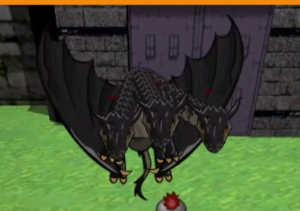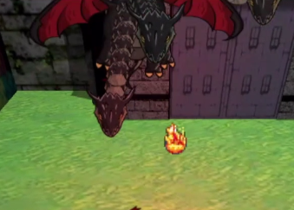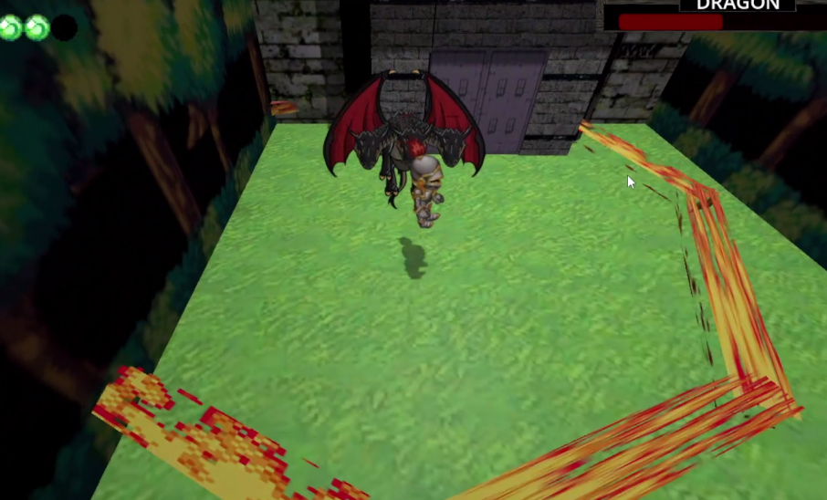

## Boss Two – Phase One | A trick fight to catch the player off guard to prepare them for the final boss.

This boss seems simple and essentially attacks like the EGG enemies by just walking towards the

player.

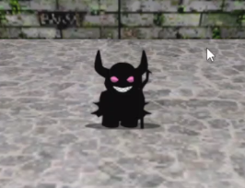

The trick here is that he is just a trick and when beaten will smash the floor the player is on.

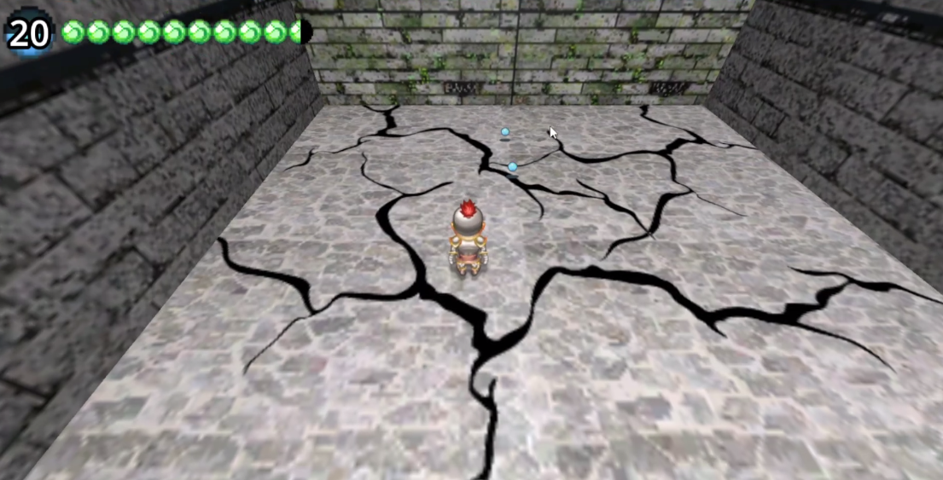

This will lead the player to the real final boss, which much like the trick pulled here, is very unpredictable.

## Final boss – Phase II | The final challenge of the game.

This boss frequently and quickly uses every attack the game has. The attacks include chasing the player, warping, creating shockwaves, and shooting fireballs randomly in quick succession. It is the ultimate test of whether the player has learned the game mechanics or not.

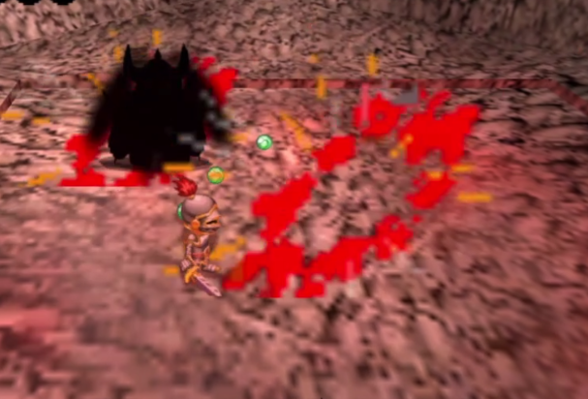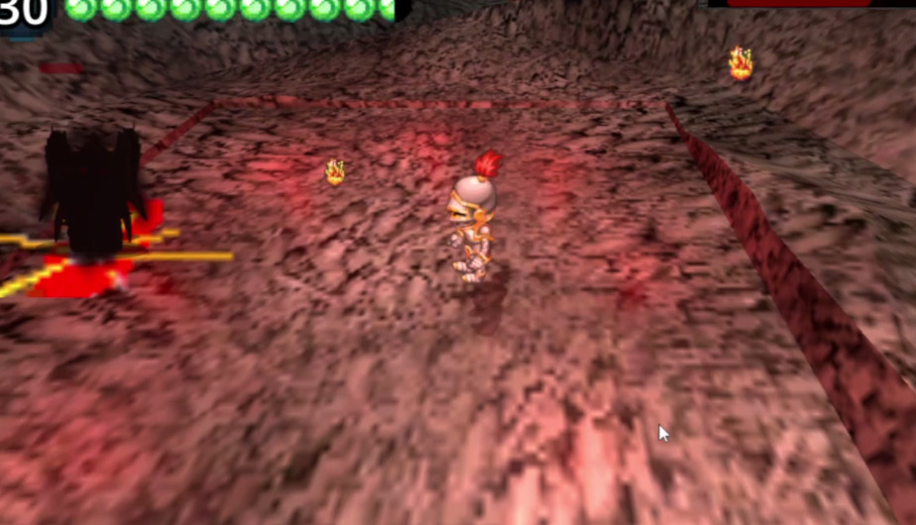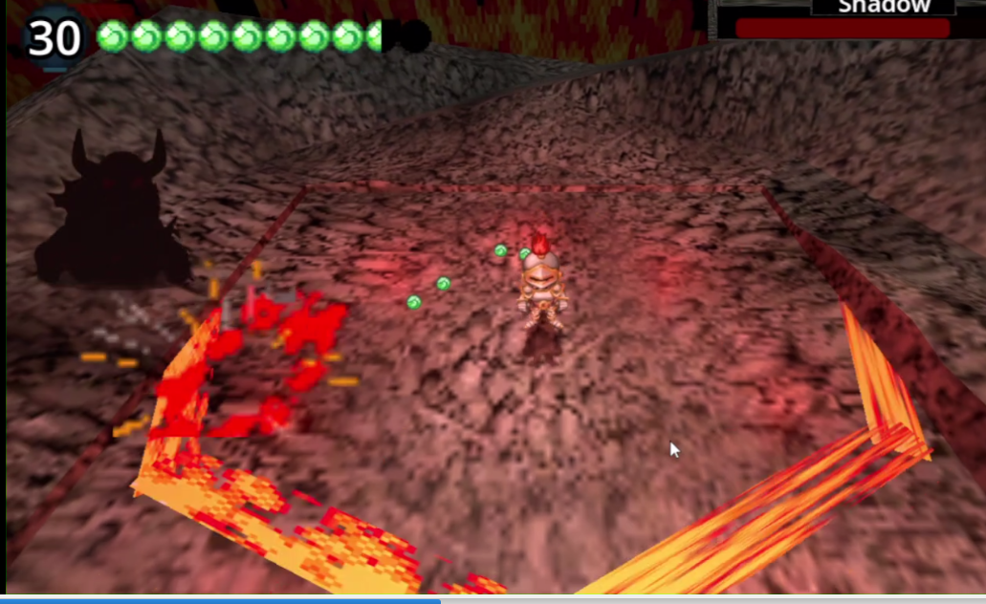

# Reports

Since finding and fixing any errors various users run into is top priority, there will be a report form available to all players to report any issues they run across. The following is the template for the form without the email that will be used for communication.

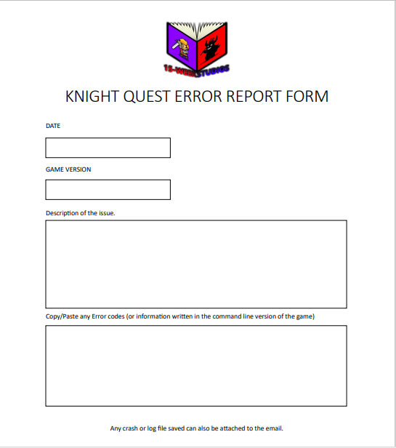

The form simply needs the date and version number, to help determine if the error is new, a fix was attempted prior and failed, etc. The Description is for the purpose of recreating the Bug, this will make it easier to determine what might be cause it. And the final field is a copy/paste version of any error or command line printouts the user may have gotten to try to isolate what might have causes the issue.

# Testing Plan

Testing for Knight quest is primarily going to be done through user testing. The purpose of the user testing is going focus on three areas,

1. Bug hunting – to find any glitches, exploits, or unexpected results that may have slipped through development.
2. User experience – to gauge the user’s reaction to the game. i.e., did they enjoy the game or did certain scenarios confuse them.
3. Game balancing – to gauge what changes should be made to damage, states, enemy placement, or boss stats.

The use testing will be Moderated, either in person or via a communication service, such as Zoom. This will allow more engagement with the user to specifically test different questions:

* Was the player able to figure out the controls?
* Was the player able to figure out a path forward?
* Did the player engage with the enemies in the game or seek to avoid them?
* How many attempts at each puzzle?
* How many attempts at each boss?
* What level was the player at when they attempted different rooms?
* Is there any additional limits to the computer hardware the user is using?

While simple, watching some users actually play through the game will not only showcase any problems that may have been missed during development, it will also allow the developer to take notes on important issues surrounding game design decisions, balance, and difficultly.

With the information from user testing, 15-week studios will be able to determine if the game is ready for deployment, or if any changes or adjustments need to be made.

# Deployment Plan

Deployment of Knight Quest is simplified by the basic set up of the Game itself. The Game does not need to be installed. As long as the executable files are located in the same folder as the Dynamic Link Library (.dll) files, running the executable will start the game. Delivery is as simple as making the package download available to the public.

With that, the deployment plan is going to be centered around three important categories: time, documentation, and communication.

## Time:

Once user testing is done and any required fixes or rebalancing is completed a date will be picked out when the download will become available to all clients and users.

## Documentation:

* The version of the software will be tracked and correlated with the games GitHub repository.
  + This is to ensure that all changes are easily discernable and older variations of the source code are available in case any new versions introduce or exacerbate bugs or problems. Certain documentation will also be available to the users as it is updated to alert them to how the program works, and any major changes or updates that where necessary.
* A simple .txt file will be included with each download package with instructions on how to run the game, control the game, update the game, and where to send error reports, comments, complaints, or reviews.
* The Error report pdf will also be included in the download package to ensure each download has easy access to it if it is needed.

## Customer Communication:

During deployment customer communication will be a top priority. Bugs and glitches were a high priority during development and user testing, however, once the product hits market, communicating problem directly to 15-weeks studios will ensure that customers remain satisfied. This will be done though two communication channels, an email address, and social media direct messaging. The error report form is the preferred method of detailing issues. However, any and all communication will be considered during deployment so 15-weeks studio can ensure all users that they are taken seriously and will be worked on as soon as possible.

Customer satisfaction and quality of the software will be the two focal points of Knight Quests deployment, and by keeping communications open, keeping the users informed, and keeping accurate documentation we will be able to handle those two essential points.

# Maintenance Plan

The maintenance plan will consist of taking communication from users, through error reports or otherwise, and cataloging the data based on game version and type of issue. Maintenance will involve monthly bugfixes and updates, however depending on the severity of the issues received some emergency patches may be scheduled and released.

Issues will be broken down into two categories: Major and Minor issues.

## Major Issues:

These are game breaking or crashes or bugs that take away from the user experience. With that, these issues will be met with acknowledgment through different communications, such as an email list or social media post. Afterwards, priority will be to fix the issue, test the fix, and deploy the new version of the game as soon as possible.

Communication is going to be high priority with Major issues to ensure customers know the issue as been found, know that is being worked on, and know when the fix is rolled out.

Once fixed, the new game version and the changes made will be documented.

## Minor Issues:

Minor issues are issues that do not take away from gameplay. For example, small, unexpected results, such as an enemy getting stuck in a wall. This issue cannot be ignored, but do not raise to the level of breaking a standardized once a month version rollout. With that, these issues will be documented together based on their possible relation to one another, and each issue will go through a smaller version of the development process. This will allow the problems to be studied, broken down into different tasks, completed, and tested before one large fix is released once a month.

Once released the new game version and patch notes will be documented. The patch notes will also be available to the users so they can be updated on what changes were made.

The Maintenance plan is centered around keeping communication open, determining what is a high priority, ensuring each patch is tested and proper, and keeping track of all changes made through documentation and source control. 15-weeks studio’s goal is to ensure feedback is heard and the program remains stable and playable.

# System Architecture

Describe and diagram the system architecture. This section is set aside to document where code lives and runs. A graphical map of a live system works nicely here. Additionally, if it was necessary to employ any type of record-locking scheme, this is the place to discuss that.

Source code for the Godot engine is always based on the location of the Godot file. With that, the engine understands the location of the files using the “res:// “ file path and automatically replaces that with the current file path of the engine.

The following is the file architecture from the course folder:

* res://
  + 3d_prefabs/
  + FLOORS/
  + GLOBALS/
    - MAIN/
    - PLAYER/
  + NPC/
  + ROOMS/
    - Final_rooms/
  + SCENES/
    - EFFECTS/
    - ENEMIES/
    - GUI/
    - Spawns/
  + SOUNDS/
  + SPRITES/
    - BACKGROUND OBJECTS/
    - ENEMY_SPRITES/
    - FILE/
    - NPCS/
    - player_sprites/

## Source Code Structure

Source code for the Godot engine is always based on the location of the Godot file. With that, the engine understands the location of the files using the “res:// “ file path and automatically replaces that with the current file path of the engine.

Source code structure introduction. The following is a summary of the source code directories and their contents:

|  |  |
| --- | --- |
| **Code Directory** | |
| **Directory** | **Usage** |
| res:// | Wherever the Godot file is opened from is references as the source folder  Contains no useable scripts itself |
| 3d_prefabs/ | Folder that contain various exported 3D structures and their associated materials. |
| FLOORS/ | Contains various prefabricated collision based objects that are native to the Godot engine |
| GLOBALS/ | Contains various Global values that are always present when the game is running. |
| GLOBALS/MAIN/ | Contains several modules that contain re-usable code for the rest of the program. |
| GLOBALS/PLAYER/ | Contains the Player object and the scripts to control the player |
| NPC/ | Contains a few NPC objects that can be instantiated in any scene |
| ROOMS/ | Contains several programmed and laid out scenes that represent rooms the player can enter. |
| ROOMS/Final_rooms/ | Contains the more complex rooms the player enters during the second half of the game |
| SCENES/ | Contains several scenes and their associated C# scripts. |
| SCENES/EFFECTS/ | Contains several scenes that animate through effects and then destroy themselves. |
| SCENES/ENEMIES/ | Contains the various enemy scenes and their associated AI. |
| SCENES/GUI/ | Contains all 2D interfaces that overlay the 3D environment |
| SCENES/Spawns/ | Contains Interactive scenes that can be instantiated and used by the player. |
| SOUNDS/ | Contains all of the .wav or .mp3 files used during the games runtime. |
| SPRITES/ | Contains the various sprites used through the game |
| SPRITES/BACKGROUND OBJECTS/ | Contains background specific sprites that are larger and typically playout far in the background of 3D scenes |
| SPRITES/ENEMY_SPRITES/ | Contains various sprite sheets for the enemies of the game |
| SPRITES/FILE/ | Contains all other ambient sprites that are based on single frames. |
| SPRITES/NPCS/ | Contains the various NPC Sprite Sheets. |
| SPRITES/player_sprites/ | Contains the Player specific Sprite Sheets. |
| *\*Highlighted rows indicate directories containing source code.* | |

# Executables

Describe the executables that are a part of this project. If there are multiple executables break out each one into its own heading and give its name and a description of what function it plays in the system.

### Project source file (project.Godot)

The source file which defines the source folder and associates the Godot files with one another. Required by the Godot engine.

### Game executable file (KnightQuest.exe)

The game executable file that uses the data_Game_windows_x86_64 folder included with it to start and run the game.

### Game executable file with command prompt support (KnightQuest.console.exe)

The game executable file that uses the data_Game_windows_x86_64 folder included with it to start and run the game with a command prompt to print out errors or in game print commands.

# Code Architecture

The system is logically based on a few simple concepts of game design. The way it works is each scene will have various object in its scene tree. These objects are all considered Classes by C# and take up a specific location in the 3D X,Y,Z plane. The system is mainly built around four important questions,

1. Where those objects are on the plan, and the objects’ purpose at the position. For example, a walls location is mento to keep the player from being in that location
2. What controls the object’s positioning. For example, the player will be controlled by the User, the enemies will be control by code.
3. What happens when two objects share the same location. For example, an enemy and player in the same location will take away some player health as well as throw the player back.
4. What creates and destroys these positional objects. For example, a sword swing will create a hitbox object.

With that, the system is built around micromanaging each of these questions with C# as the game runs. To showcase this, I will show the UML for the Physics branch of objects. Since this one is large and difficult to read, I will include a full UML with the documentation in the git repository.

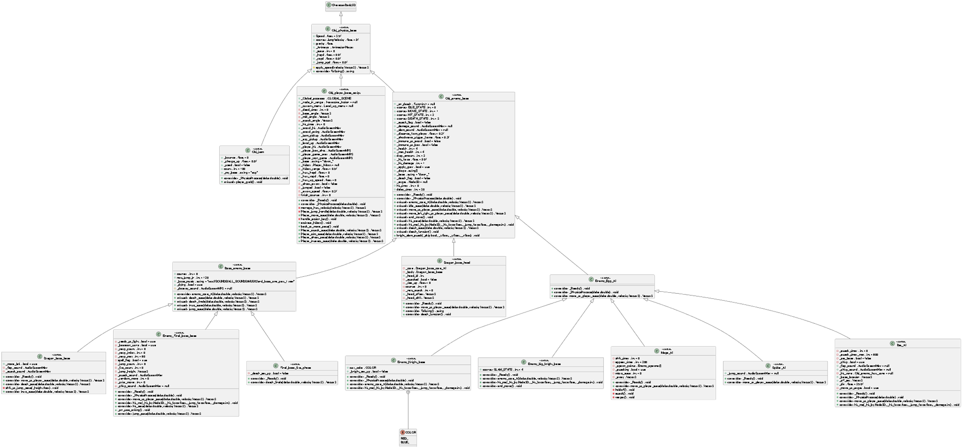

What this UML is showing is that each physics object’s position wants to be on a floor. If it is not on a floor the object’s Y value will be changed until it is. Each of these physics’ objects branch off into the player, enemy, and item objects. These inherit the physics problem of always being on the floor and addresses unique Positioning each object faces. The item’s positioning is always randomly applied and slows down to 0. If it hits a wall, it will reverse its direction. The player’s position will be controlled by the user. W to move UP, D to move right, S to move down, and A to move left. The enemy will be controlled by AI and typically seek to be in the same location the player is in to damage them.

The UML diagram goes into specific details, but despite the complexity each one is just micromanaging where the object is, how it moves, and what it does when it enters the same location as another object; albeit in slightly different ways to keep the game interesting.

## Database or Data Store

Data for the game is stored in several .save files. These are simple text documents with information that the Godot information can read and interpret.

|  |  |  |  |  |
| --- | --- | --- | --- | --- |
|  |  |  |  |  |
| Data in the game is held in List Data structures |  | This is written to a file |  | Then encypted in the file to protect the information |

This file can be retrieved at any time and the stats and accomplishments can be restored through the load screen.

External Files & Data

If any external files are used and/or if information is stored in the Registry, that information should be documented here. If this information needs security of some type that should be documented here as well. Be sure to address WHAT security steps have been taken if they are required.

The Knight Quest executable is not installed, it is just run. Therefore, all copies of the game will come with a file labeled “data_Game_windows_x86_64”. This file continues the library files and assets the game requires to run and must be paired with the executable file, or the game will not run.

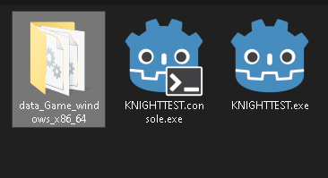

Data file required for game to run

In addition to that, all save files will be save to,

C:\Users\[USER]\AppData\Roaming\Godot\app_userdata\Game

They are not required to run the game, but the saved game will be encrypted and stored in this location with the names save0.save, save1.save, and save2.save, signifying the 3 save slots the game has.

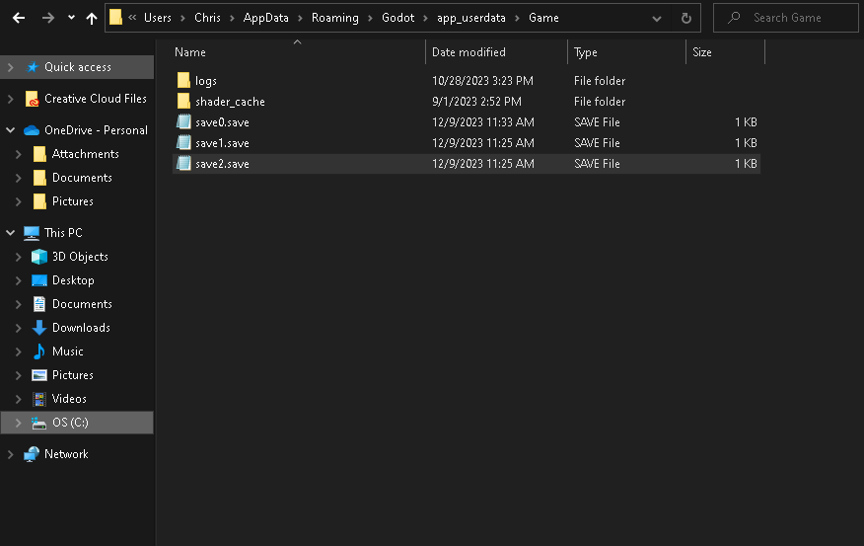

2Save games stored in the %appdata% folder

Programming Language | C#.NET

Provide details about what language the project is written in. – Be sure to identify any components, references and/or external DLLS.

The program is written in C# and requires both the .NET SDK installed (<https://dotnet.microsoft.com/en-us/download>) and a specific version of the Godot Engine with C# enabled (<https://godotengine.org/download/windows/>).

.NET-enabled version of Godot [1]. All C# scripts must use the “using Godot;” to import the required Godot libraries.

While no other external DLLS are needed, the Godot Engine uses the C# language in a very specific way. The engine contains .tscn which stands for a text scene (<https://docs.godotengine.org/en/stable/contributing/development/file_formats/tscn.html>). The scenes are Made up of a hierarchy of Nodes, which can be various in game objects. For example, Node3D, which has positioning information; Sprite3D, which is a descendent of Node3D that also contains sprite information; as well as many other Node that build each game scene out.

C# scripts specifically define Classes and are attached to one of these nodes. With that, once a class is defined and reference from a Node, the node and class are essentially the same instance.

For instance,

Here I have one Node in the Scene tree circled in red.

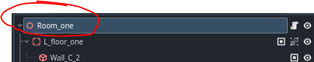

This node has the Room_set_up.cs file attached to it which defines the Room_set_up Class.

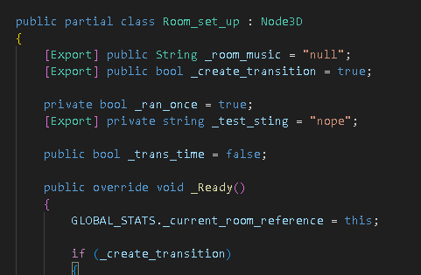

Now that this link has been made any changes or references to the “Room_one” node can be made by referencing the Room_set_up class. And any instantiated “Room_one” Objects will be another instance of the Room_set_up class.

This is a simple feature included with the Godot engine, however, understanding that attaching a script is essentially making the Node a part of it is pivotal to understanding the C# code. It is what allows the on-screen Nodes to reference each other and their children with code like GetParent, GetChild, and GetNode.

Project Classes

Classes within the project are used to abstract re-usable pieces of code. Classes are also used to group related values, known as properties. The project utilizes these classes:

### Player Controller | Obj_player_base_script.cs

An important class that verifies player input. The class is state driven and depending on what state the player object is in the users controls will be freed or restricted.

### Physics Base for all Objects | Obj_physics_base.cs

A base class that always seeks to be on the floor. If it isn’t it will apply Gravity until it is.

### Check in game flags and begins events | Event_Summoner.cs

This class typically is used when a new scene starts. It will check to see if the suppled flag is active or not. If it is it will run the _summon_event() that can be inherited and overwritten to do whatever it needs to do.

### A projectile class that is not effected by physics | Obj_projectile_parent.cs

A base class for any object that travels on the 3D plan but is not affected by Gravity. It keeps track of it’s destroyed status, and if it is still active it will run the _active_function() method until it is destroyed. This can be inherited and the _active_function() method can be overwritten to do whatever is required of the projectile.

### The base class for all enimes | Obj_enemy_base.cs

This class defines basic enemy functions and supplies a state system for enemies to use. This class can be inherited and it’s idle, move, hit, and death states can be overwritten to make each enemy unique.

### Bass class for all bosses | Boss_enemy_base.cs

This override the Obj_enemy_base and adds more states to allow the boss to enter heavy attacks, jump, and provide an introduction for themselves. Much like the enemy base class, this class can be inherited by bosses and overwritten to make the boss unquie.

### Core boss mechanics | Boss_core_AI.cs

This class runs in conjunction with the boss and handles their health and unique boss functions. It’s _main_function() method will always run as long as the boss is not defeated yet.

### Objects to change scenes | Door_base.cs

When the player collides with a door the transition function is called to change scene. Override can be used to define what room and what location the player moves to.

### In game interactive buttons that can be pushed | Button_base.cs

Buttons the player can jump and push down. Once pushed the button will run the _on_press() function once. This class can be inherited and the _on_press() method can be overwritten to change it’s behavior. By default a button will contain a reference to an in game flag and change it to true once presses.

### A locked door that blocks the player | Locked_door_base.cs

This class is essentially a wall that moves out of the way when a certain condition is true. This condition can be defined by overriding the _door_trigger() method. By default, it looks for specific game flags to be true.

Project Modules

Modules are used for procedural based code that does not require state data like class modules do. Complete the introduction to modules.

### Defines global functionality | GLOBAL_FUNCTIONS.cs

Class that contains functionality that all instances in the game can use. This include functions that can change scenes, manage data, choose from data, and create instances (Enemy / Effects/ Projectiles)

### Defines the players current status | GLOBAL_STATS.cs

Class that manages the important overarching player status. This includes keeping track of the information, saving the information to a file, and loading the information from a file.

Program Start and End Flow

Describe and then diagram the program flow. Here is an example of program flow from a fat-client based PC application.

The general program flow is based on the game engine running blocks of code 60 times a second with the code mainly being centered around either reacting off of user input or interacting with other objects on the screen.

With that the program will start at the title screen and wait for the user to click either new game or load game, if they choose new game, they name the player is move to the default start location with the default stats, if they load the game the code will interpret the appropriate file and override the stats and location with the saved data. Once loaded the game works on a simple cycle of the player working though scenes and interacting with enemies to determine if they lose or not. If they ever run out of health, it is a game over.

**START**

Knight_Quest.exe

LOAD GAME? OK?

Move plater to new scene

Read .save file and override default stat’s and locations

Yes

No

Touch Door?

Hit by Enemy?Collision

Hit by projectile?

HP < 0?

**GAME OVER**

Game environment running at 60 steps a second

Yes

No

Yes

Yes

Yes

Apply “hurt” velocity

Apply damage

Summary

*Knight Quest* is a small project made for a short amount of time that was meant to be simple and fun. With that, the programming is built around very simple concepts of where objects are, how they got there, where they are moving to, and what happens when two collide. To ensure its simplicity other advanced game development attributes are not used, such as armatures and animations for 3d characters.

This purely position based logic allows the programmer to use the C# variant of the Godot engine and the .NET framework to easily manage and control how objects interact with each other. It allows for several base classes to inherit properties from, as well as several global modules that contain useful functions used throughout the game. Outside of movement and interactions, there is minimal aesthetic programming to ensure sprites and effects match up with the interactions on the screen.

There is also a leveling system that will allow the player to grow and affect his in-game environment in different ways to accomplish tasks easier. As the player grows, they will be able to save their progress through the engine by going to the save menu. This will write their current game stats and accomplishments to a file so the load menu can restore it for them later.

All of this comes together in this small action-adventure game, that allows players to explore this small world and challenge puzzles and enemies that progressively get tougher. From the beginning enemies that just serve to teach the player basic controls to the final boss which ensures the player learned those controls, *Knight Quest* is a small simple game meant for a wide audience of different players to jump into an enjoy.

# APPENDIX B (BUILD AND RELEASE PROCESS)

An exported Godot engine comes with two versions of the exe, with one running with command prompt, as well as a windows specific folder filled with all of the .dll files required for the game to run. In order to implement a new build, the older files need to be removed and replaced with the new files.

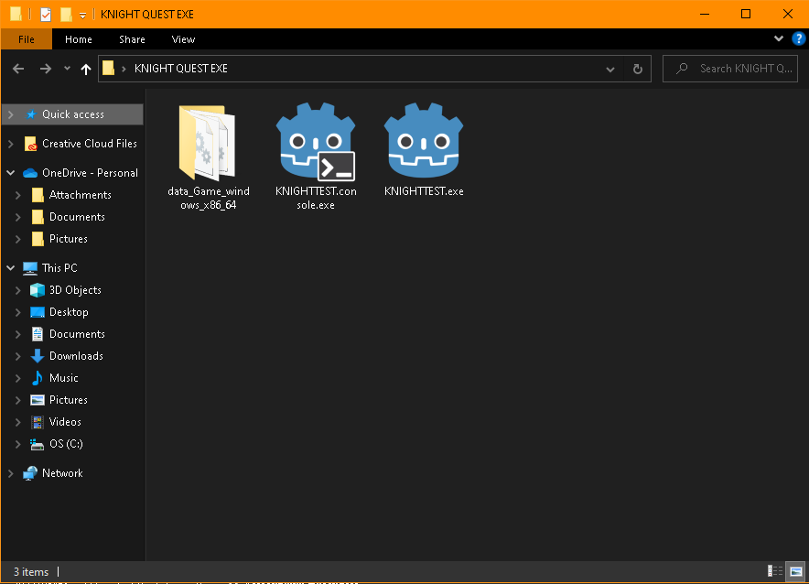

All other associated save files will be contained in the %AppData% folder and will still work with any new versions.

# APPENDIX C (CLIENT INSTALLATION INSTRUCTIONS)

The game will run on any computer running Windows 7 or higher. No actual installation is required, as long as the executable file is in the same directory as the required .dll files the game will start and run.

When testing it with different systems, It is however recommended that the system have at least

Windows 10 or higher

4 GB of ram

And a processor with OpenGL 2.1 Support.

Support for other operating systems is not available at this time.

# APPENDIX D (DEVELOPER SETUP INSTRUCTIONS)

The program is written in C# and requires both the .NET SDK installed and a specific version of the Godot Engine with C# enabled.

## .NET SDK

<https://dotnet.microsoft.com/en-us/download>

Download and run the installer to install the .NET environment required to compile the source code.

## .NET-enabled version of Godot.

<https://godotengine.org/download/windows/>

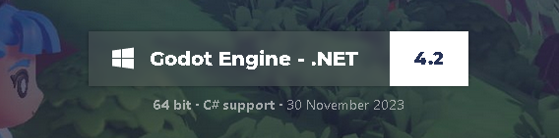

Godot engine does s not need to be installed, simply unzip the file and run the executable to start the program.

The Visual studio code and C# Godot plugin is also recommended when working with the projects source code.

## Visual Studio Code

<https://code.visualstudio.com/>

## C# Tools for Godot - Visual Studio Marketplace

<https://marketplace.visualstudio.com/items?itemName=neikeq.godot-csharp-vscode>

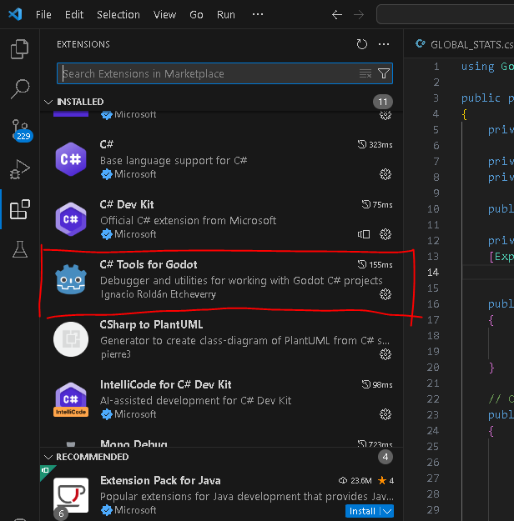 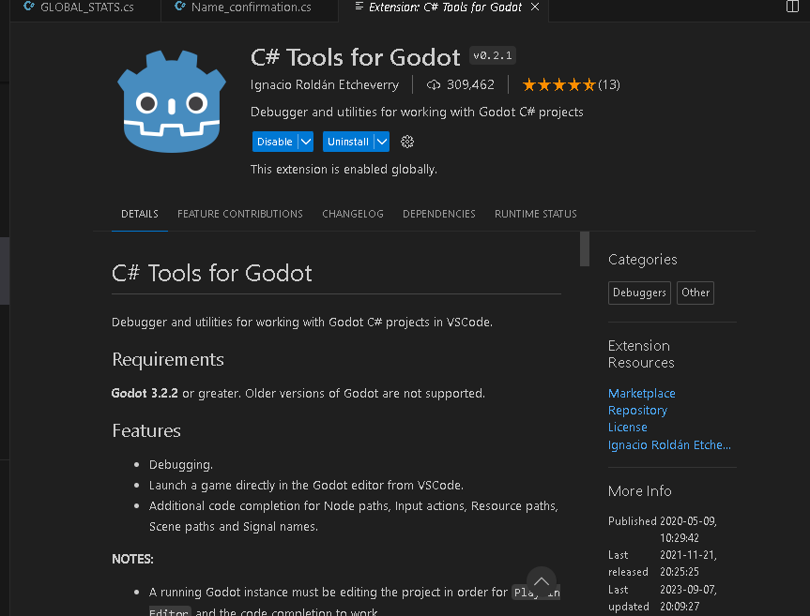

This can be installed and enabled from the Visual studio code extension browser

# APPENDIX E (Catchall Project Reflection)

## What went well:

The overall project went smoothly since there was also a solid goal in mind. With that, despite having to jump around during the development to ensure certain requirements where met, such as need to make a parent class for an enemy because the player class needed the reference to continue, there was always a continues flow of tasks being completed. The order might those tasks were completed in may have been a bit sporadic, however, consistently seeing the game take shape is not only a good sign of the overall progress being made, but a good morality boost to know that the work being put into it is accomplishing something.

## What went wrong:

Godot is fairly unstable with a few things, there seems to be a lot of problems with retaining settings and data For example, the Button puzzle, where the button had to be hit so all of the buttons’ colors match to open the door, defaults at sharing one material. That means if you change one button material, all buttons use that material, and they would all change. There is a setting to ensure that each material is unique, however, each reload of the program would change the setting back to default. This issue is actually fixed in Godot version 4.2, however updating to the new version created other compatibility issues, where I had to reimport a lot of assets. Godot also crashes now and then, and the debugger had issues with where it would lock up during scene changes. However, frequent saving and source control made these issues easy to overcome.

## What could've been done better:

What I could have done better all revolves around the planning stage. It became apparent during development that planning the program out would have been better if it started at a purely functional approach and worked upwards towards more specific elements. For example, the approach for this project was along the lines of what objects the game will need, such as players, enemies, items, etc., and then making tasks that have to do with each specific object. What would have been better is to consider what all objects need, than breaking it down into specific as objects inherit each base object. For example, a parent class for all objects, then for all physics objects, then for all movable objects, etc. this would allow the developers to not only further consolidate the code, but also always have some type of reference to work with. This means that the progress would require less jumping around and have a much better chance of just moving forward.

I would also do a bit of research into the game engine I had in mind. Where in this case a bit of research into Godot would have showcased that version 4.0+ is fairly new, a big change, and has stability issues. I may have been better off going with something such as Godot 3.5, which does not have the newer features, but is stable with plenty of documentation.

## Future of the Project:

Knight Quest was a project created purely for experimenting with and accomplishing software programing tasks. With that, the future of the project would be more focused on the game design elements of it, such as introducing more characters, making a solid story, worldbuilding, etc. Essentially, the project is now functional, but I would want to take it a step further and give it some more personality with hand drawn sprites, new music, and more entertaining characters and story. The project worked as an excellent practice in software development, but now that the foundation is solid, I want to be focus on being more creative as the project goes forward.

1. Further recommendation on with Godot specific C# code can be found in APPENDIX D